Project Initiation Document (PID)
OfstedReady – Digital System for Continuous Ofsted Readiness in Degree Apprenticeships
Module
Industrial Consulting Project (QHO635)
Assessment
AE1 – Group Portfolio Project Initiation Document (PID)
Project Sponsor
Dr Ajmal
Supporting Tutor
Shiv
Group Members
Krishna | Project Lead
Larisha | Technical Lead
Alin | Frontend Developer
Ashik | UX Research & Documentation

1. Project Summary & Introduction
OfstedReady is a web-based digital platform designed to support continuous Ofsted readiness within degree apprenticeship programmes. The project was developed in response to operational challenges identified within academic programme management, particularly around learner monitoring, evidence organisation, assessment tracking, and programme reporting.
Many degree apprenticeship programmes currently rely on fragmented spreadsheets, disconnected documents, and manual administrative processes to manage learner data, schedules, grades, and inspection preparation evidence. These processes can lead to inefficiencies, inconsistent reporting, difficulties identifying at-risk learners, and challenges during Ofsted inspections.
The purpose of the OfstedReady platform is to centralise and simplify these operational processes through automation and structured digital workflows. The project focuses on developing a practical Minimum Viable Product (MVP) capable of supporting core programme monitoring and administrative tasks.
Following requirements gathering and stakeholder discussions with the project sponsor, the team identified two high-priority automation opportunities:
- Module Delivery Schedule Generator
- Grade Import with Student Overview
The Schedule Generator enables programme staff to automatically generate future academic schedules using semester dates and institutional holiday periods. The Grade Import functionality allows programme teams to upload learner grade data using CSV or Excel files and automatically populate a standardised student overview dashboard.
The project combines principles of user-centred design, Agile-inspired sprint planning, accessibility, and practical software engineering. The proposed solution was developed using React for frontend development, Node.js and Express for backend services, and SQLite for lightweight database management.
The project aims to improve efficiency, reduce manual administrative workload, improve learner visibility, and support ongoing inspection readiness.

2. Project Objectives
The main objective of the OfstedReady project is to design and implement a practical digital platform that improves operational management and continuous Ofsted readiness within degree apprenticeship programmes.
The key project objectives are:
- Develop a functional web-based MVP for programme monitoring and administrative automation.
- Implement a Module Delivery Schedule Generator capable of creating academic schedules using semester and holiday inputs.
- Implement a Grade Import feature that uploads learner grades from CSV or Excel files.
- Automatically generate a Student Overview dashboard to improve learner tracking.
- Improve programme visibility through dashboard-based reporting.
- Support role-based access for different user types.
- Apply accessibility and usability principles within the prototype design.
- Demonstrate Agile teamwork, sprint planning, and collaborative software development.
The project also aims to provide a scalable foundation for future system enhancements such as evidence management, KSB mapping, analytics, and audit tracking.

3. Requirements
The project requirements were gathered through supervisor discussions, client meetings, UX research, and internal sprint planning sessions.
The main functional requirements identified for the MVP are:
- User authentication and role-based access control.
- Dashboard for programme overview and learner monitoring.
- Module Delivery Schedule Generator.
- Grade Import functionality using CSV or Excel files.
- Student Overview display with learner performance information.
- Data validation during uploads.
- Basic reporting and visibility of learner progress.
- Database storage for learner, module, and schedule information.
The system must also support the following non-functional requirements:
- Simple and accessible user interface.
- Responsive layout.
- Data consistency and validation.
- Secure authentication handling.
- Easy local development and deployment.
- Maintainable database structure.
The team conducted UX and accessibility research using GOV.UK design principles, WCAG accessibility guidance, and usability heuristics to ensure the interface design remained simple, professional, and user-focused.

4. Scope and Exclusions
The scope of the project focuses on delivering a realistic and achievable MVP within the project timeframe.
Included Within Scope
The core MVP features include:
- User authentication
- Dashboard interface
- Module Delivery Schedule Generator
- Grade Import and Student Overview
- SQLite database implementation
- Basic reporting functionality
- Frontend prototype implementation
Excluded From Scope
The following features were identified as future enhancements and therefore excluded from the MVP implementation:
- Advanced analytics dashboards
- Full evidence management system
- Complete KSB mapping functionality
- Workplace visit tracking
- Advanced audit reporting
- Live integration with university systems
- Advanced notification systems
This prioritisation ensured the project remained technically achievable while still demonstrating meaningful value and scalability.

6. Team roles and responsibilities
Team Member | Role | Responsibilities
Krishna | Project Lead | Sprint coordination, supervisor/client communication, meeting organization, documentation review
Larisha | Technical Lead | Database design, backend planning, technical architecture
Alin | Frontend Developer | Prototype implementation, dashboard UI, frontend structure
Ashik | UX Research & Documentation | UX research, accessibility review, documentation support
The project team consisted of four members with allocated responsibilities based on technical strengths and project requirements.

The team collaborated using Agile-inspired sprint planning and regular communication to coordinate implementation and deliverables.
8. Project Milestones & Management
The project followed a sprint-based development structure consisting of three main project stages.
Sprint 1 – Research & Planning
Activities completed:
- Requirements gathering
- Stakeholder discussions
- Technical research
- Initial wireframes
- MVP identification
- Project planning
Outputs:
- Requirements overview
- Initial architecture proposal
- Sprint planning evidence
Sprint 2 – UX & Prototype Development
- Activities completed:
- UX research
- Accessibility review
- Frontend prototype development
- SQLite database implementation
- Prototype refinement
Outputs:
- UX report
- Dashboard prototype
- Database schema
- Prototype screenshots
Sprint 3 – Implementation & Evaluation
Activities completed:
- MVP refinement
- Testing
- Evaluation
- Final documentation
- Presentation preparation
Outputs:
- Working MVP
- Testing evidence
- Final PID
- Presentation materials
The team maintained regular communication through meetings and progress reviews to ensure milestones were completed within the project timeline.

7. Project Deliverables
The project produced several deliverables throughout the sprint lifecycle.
The main deliverables included:
- Requirements documentation
- Technical architecture proposal
- UX research report
- Frontend prototype screens
- SQLite database schema
- Grade import workflow
- Schedule generation logic
- Sprint planning evidence
- Meeting evidence documentation
- Testing plans and evaluation summaries
- Final MVP prototype
8. User Flow Diagram
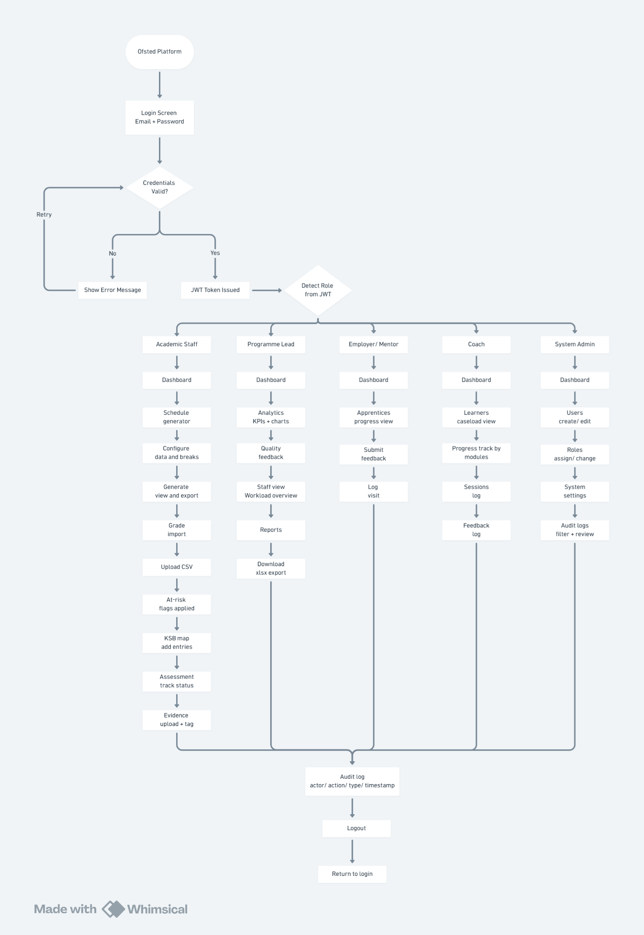

9. Implementation
The OfstedReady platform was implemented using modern web technologies to support maintainability, scalability, and efficient MVP development.
 | Technology | Purpose
Frontend
Frontend | React | Component based UI framework
UI Styling | Tailwind CSS | Responsive styling
Reporting | ExelJS/ xlsx | Excel generation and file reading from clients end.
Dashboard | Recharts | Data visualization- bar charts, area charts, radar charts
Validations | React Hook Form | Validation and Form state management
Backend
Backend | Node.js | JavaScript runtime for API server
Routing | Express.js | HTTP routing, middleware and REST API framework.
Authentication | JSON Web Tokens | Stateless authentication tokens
Reporting | ExcelJS | Excel report generation (grade reports, schedule export)
 | PapaParse | Server-side CSV parsing for grade imports
 | Multer | Multiple file upload handling
Database
Database | SQLite | Single file database and zero configuration.  The database structure included tables for:  - Users  - Learners  - Modules  - Enrolments  - Schedules  - Assessments  - Grade import batches

Core MVP Features
Dashboard
The dashboard of academic staff appears as the first screen after login, it provides all the operational urgent information as at-risk learners, pending grades, upcoming sessions and module level evidence counts. This makes sure nothing important is missed before navigating to a specific task. Quick action buttons allow the staff to navigate quickly for the most frequently used features.
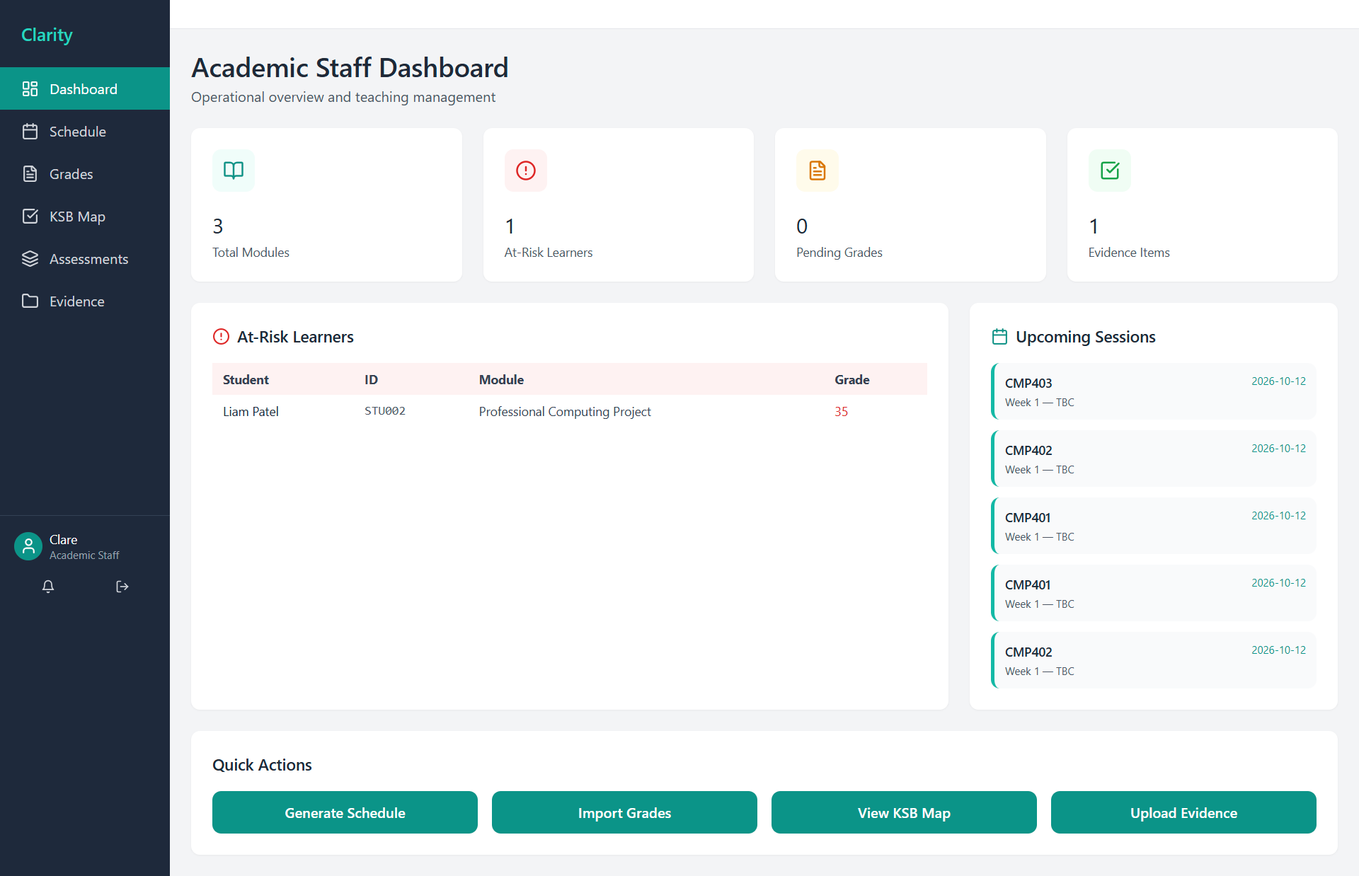

Schedule Generator
The schedule generator feature automates the creation of full academic year timetable. The staff configures the semester date range and all holidays exclusion periods, so the system generates week by week session per module. Generated schedule table is displayed as week number, date, module code and topic. Export CSV button allows the staff to download full schedule as a spreadsheet.
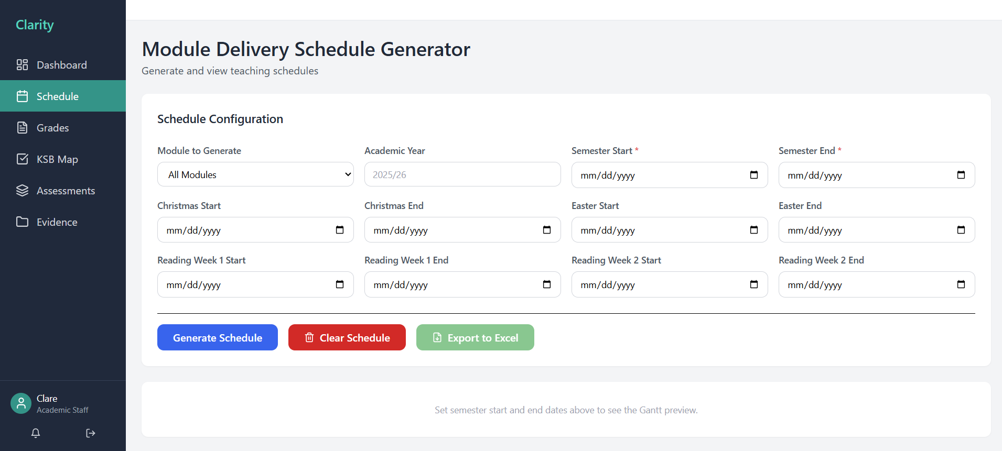
Grade Import
The core data entry workflow would be grade import, the staff uploads the CSV file, the system validates every row and maps student IDs to database records and automatically calculates pass/ fail and then flags the at risk to learners below 40% threshold. Student grade overview table automatically refreshes after importing and displays student ID, name, grade, status.
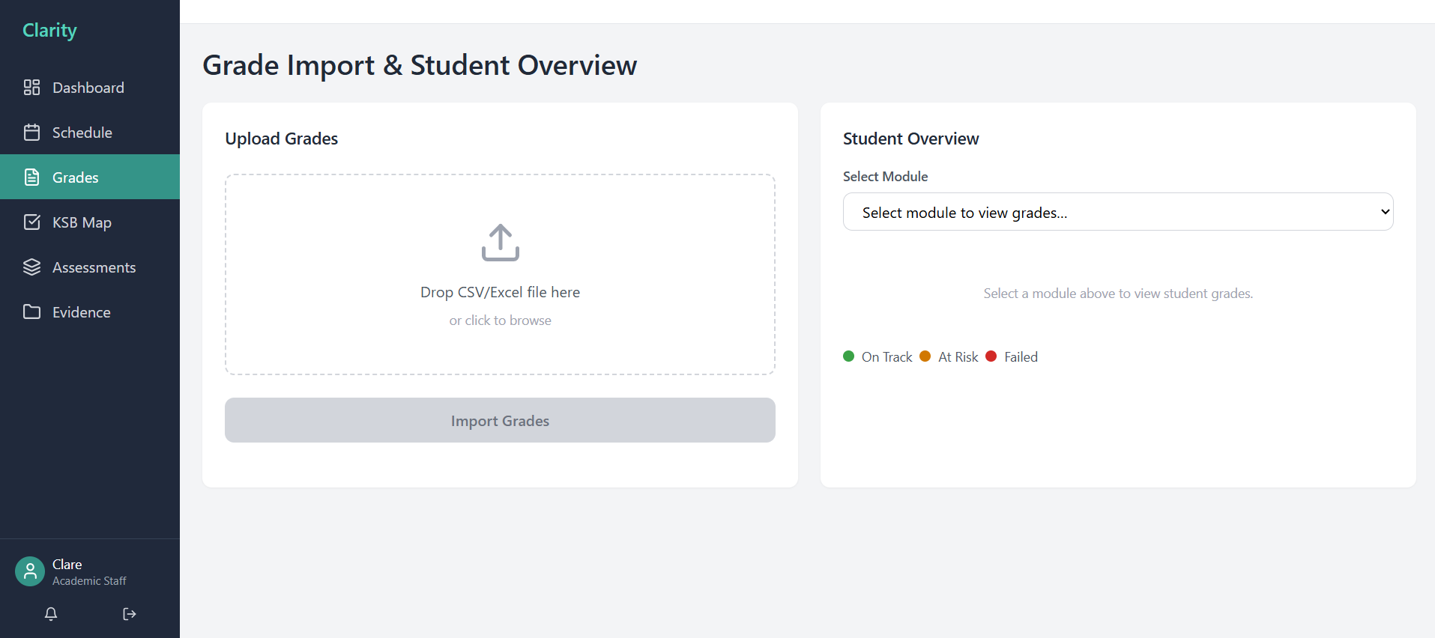

Assessment
Assessment screen provides all assessment deadlines, marking progress, review dates, external requirement across modules. This makes the work easier as there is no need of separate tracking spreadsheets. Add assessment allows to create new assessments with all necessary fields that directly populates in the screen after saving.
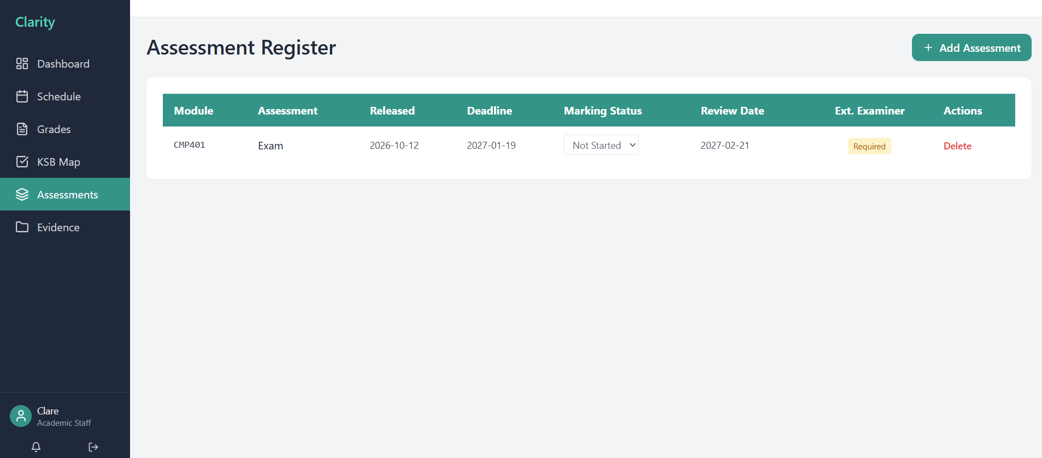
10. Testing Requirements
10.1 Testing Strategy
A credible academic evaluation for the prototype can be built from four complementary methods: heuristic review, task-based usability testing, accessibility checking and a short post-test usability questionnaire. This creates a stronger evidence chain than relying on opinion or visual polish alone.

Method | Purpose | Participants / artefacts | Output
Heuristic evaluation | Identify interface issues early using recognized design principles. | 3–5 reviewers comparing the prototype against usability heuristics. | Issue list ranked by severity (Nielsen Norman Group, 2022; Nielsen Norman Group, 2024).
Task-based usability test | Measure whether typical users can complete key workflows. | Programme lead and academic-staff scenarios using dashboard, grade import and evidence log. | Completion rate, time on task, observed errors and comments.
Accessibility review | Check the prototype against core accessibility expectations. | Keyboard testing, colour/contrast checks, table and form review against WCAG 2.2. | Accessibility findings and remediation list (W3C, 2024).
SUS questionnaire | Capture a quick, comparable measure of perceived usability. | Post-test questionnaire completed by participants. | A numerical SUS score with qualitative comments (Brooke, 1996).

10.2 Functional test scenarios
ID | Requirement
FT1 | Uploading valid CSV grade file- verifying the records imported, refreshed student overview table and at risk being flagged correctly.
FT2 | Upload CSV with invalid rows- display error banner
FT3 | Add KSB entry- matrix updates being verified and coverage % is recalculated
FT4 | Generate schedules- system verifies that excluded weeks do not appear in the output table
FT5 | Login as employer- System displays verified dashboard, feedback.
FT6 | Create a new user account as System admin- verify user list, login works with provided credentials with correct role.
FT7 | As a Programme Leader download necessary xlsx files with live data

10.3 Non Functional test scenarios
ID | Requirement
NT1 | Verify passwords are encrypted after user creation – confirm plain text password is not persistent
NT2 | Dashboard loads with limited time after user logs in
NT3 | Use non-CSV file to import grade- system verifies and rejects the upload with error message
NT4 | Ensure imports are completed in less than seconds
NT5 | Check Colour contrast of all status badge and stat card values
NT6 | Ensure the system is assessable for the assigned roles

11. Results
The project successfully produced a functional MVP prototype aligned with the agreed project scope and stakeholder expectations.
The team successfully completed:
- Dashboard implementation
- Schedule generation workflow
- Grade import functionality
- SQLite database integration
- UX research and accessibility review
- Sprint coordination and project documentation
The project demonstrated that automation can improve programme visibility and reduce manual administrative processes.
Feedback from internal reviews highlighted strengths including:
- Clear interface layout
- Practical workflow design
- Strong MVP prioritisation
- Professional documentation structure
The evaluation process also identified opportunities for future enhancement including additional analytics, reporting features, and deeper evidence management capabilities.

12. Conclusions and Recommendations
The OfstedReady project successfully addressed the core objective of improving operational readiness and programme monitoring within degree apprenticeship environments.
The final MVP demonstrated practical automation features capable of improving efficiency, simplifying administrative tasks, and supporting learner visibility. The use of Agile-inspired sprint planning, UX research, stakeholder engagement, and collaborative teamwork supported the successful development of the project.
The project also demonstrated the importance of maintaining realistic MVP scope within limited development timelines. By prioritising the Schedule Generator and Grade Import functionality, the team was able to deliver meaningful outputs suitable for demonstration and evaluation.
Future recommendations include:
- Integration with institutional systems
- Advanced analytics dashboards
- Full evidence management features
- Expanded KSB mapping functionality
- Enhanced accessibility testing
- Cloud deployment and authentication improvements
Overall, the project provided a strong foundation for future development while successfully meeting the core objectives of the MVP.

References
GOV.UK (2010) Project Initiation Documentation Guidance.
Nielsen, J. (1994) Usability Heuristics for User Interface Design.
W3C (2023) Web Content Accessibility Guidelines (WCAG) 2.2.

Appendices
Appendix A – Meeting Evidence
- Supervisor meeting summaries
- Client meeting notes
- Sprint planning evidence
- Team communication evidence
Appendix B– Database Evidence
- SQLite schema
- ERD diagrams
- Sample tables
Users
Column | Type | Description
id | INTEGER (PK) | Unique user identifier
name | TEXT | User's full display name
email | TEXT (Unique) | Login email — must be unique across all users
password_hash | TEXT | bcrypt hash of user password
role | TEXT | One of:  · programme_lead  · academic_staff  · coach  · employer  · system_admin
created_at | DATETIME | Account creation timestamp

Assessments
Column | Type | Description
id | INTEGER (PK) | Unique assessment ID
module_id | INTEGER (FK → modules) | Linked module
title | TEXT | Assessment name
release_date | DATE | Date assessment is issued to learners
deadline | DATE | Submission deadline
marking_status | TEXT | not_started  · in_progress  · complete  · overdue
review_date | DATE | Internal second-marking review date
external_examiner_required | INTEGER | 1 if external examiner required

KSB mapping
Column | Type | Description
id | INTEGER (PK) | Unique KSB mapping entry ID
module_id | INTEGER (FK → modules) | Linked module
ksb_code | TEXT | KSB code (e.g. K1, S3, B2)
description | TEXT | Description of the KSB element
workplace_relevance | TEXT | Notes on how this KSB is demonstrated in the workplace

- Schedules
Column | Type | Description
id | INTEGER (PK) | Unique schedule entry ID
academic_year | TEXT | Academic year label (e.g. 2025/26)
module_id | INTEGER (FK → modules) | Linked module
week_number | INTEGER | Teaching week number
session_date | DATE | Date of the session
topic | TEXT | Session topic description
created_at | DATETIME | Schedule generation timestamp

Appendix C – AI Usage Declaration
AI tools such as ChatGPT were used to support language refinement, structure organisation, brainstorming, and clarification of technical concepts. All final content, project decisions, research verification, implementation, and critical evaluation were reviewed, edited, and validated by the project team.

